

Faiths4Change: About Us

Faiths4Change (F4C) is a small, dynamic environmental charity (no.1138834) and registered company limited by guarantee (no. 7201450) currently working in and with communities on Merseyside. Founded by the Right Reverend James Jones, former Bishop of Liverpool in partnership with senior faith and environmental leaders from across Merseyside in 2004, our work is rooted in the shared values and beliefs of caring for the earth and community as a whole; in order to create a more just and deeply sustainable world.

Our current patron is the Right Reverend Paul Bayes, Bishop of Liverpool. We have strong, supportive relationships with the Diocese of Liverpool, other denominations and world faith communities and organisations from different sectors across Merseyside.

Faiths4Change is not a religious organisation.

Faiths4Change charitable objects are:
i) To promote for the benefit of the public the conservation, protection and improvement of the physical and natural environment, and in particular to bring together faith communities to work towards improving the environment of disadvantaged communities within the North West of England.
ii) To advance the education of the public in the conservation, protection and improvement of the physical and natural environment, particularly within disadvantaged communities in the North West of England

Faiths4Change has a board of Trustees who are committed to the team and support our work on all levels. We are all committed to positive working practices and policies which actively support the development of trusted relationships with all people and deepen connections with the environment and nature. We believe in and are committed to partnership working which supports all people to develop their talents, skills and knowledge and grow flourishing neighbourhood environments.

We are a Living Wage Foundation accredited employer. We are committed to active working on the climate emergency & have begun to measure and reduce our carbon footprint.

We are active members of a number of strategic partnerships & networks including LCR Climate Partnership, Nature Connected and Cool Wirral Partnership. We are hosted by the Diocese of Liverpool and have excellent working relationships with many partner organisations from different sectors too.

COVID 19 Working

Our current team of 7 includes 4 active members - our Director, Deputy Director (Arts Coordinator for Interfaith & Environmental Development), Food & Wellbeing Coordinator (leaving) and Assistant Bookkeeper.

Our Health & Wellbeing Assistant, Administrator & Team Support team members are currently furloughed.

Our office is within St James House which is currently closed, we are all working remotely and keeping in touch via zoom, phone and email and a monthly team meeting for the whole team.

Our current partnership work includes
- Land based activities - managing existing community / school gardens including seasonal. food growing in Liverpool.
- Improving recycling rates in specific areas of Knowsley.
- Faith and climate change projects across the Liverpool City Region & in specific boroughs.

To find out more about our approach, current and past work please look at our website www.faiths4change.org.uk and our twitter and facebook pages @faiths4change
Contact Annie Merry, Director, on annie@faiths4change.org.uk

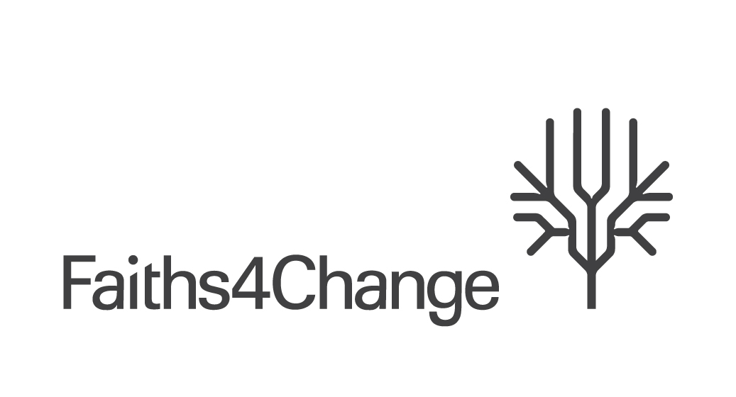

We’re recruiting - Food, Land & Wellbeing Coordinator

Our Team are passionate and highly experienced. We care about and believe in people, community, social justice and taking practical, connected action on climate change. We’re inspired by what we do, sharing and the many people we work in partnership with to create, grow and journey with to create practical projects and services and the diverse neighbourhood environments we work in.

Projects:
Faiths4Change has a number of exciting projects focused on food, land & wellbeing, some are delivered in person and others on line.

These include:
- Managing a community food garden, growing and donating fresh food to a local foodbank
- Planning the development of a community environment hub
- Managing the development of a new community garden, including developing on-line communication with Centre users and engaging with partners
- Working with primary schools to create / use resources to deliver inspiring small group sessions in gardens

Person Skills:
We are a small and friendly team who enjoy and depend on working really well together, particularly as we’re working remotely right now. We anticipate that you are:

- Passionate about people, the planet and justice.
- Have a collaborative approach – we work in partnership with a wide range of stakeholders externally and internally with other Faiths4Change team members to ensure effective, joined up and high quality project and service planning, delivery, monitoring and evaluation, financial management and reporting.
- Are versatile, quick thinking and proactive.

- Committed to our values, positive working practices and policies which actively support the development of trusted relationships with all people and deepen connections with the environment and nature.

- Committed to supporting and working with all people to develop their talents, skills, knowledge.

- Committed to environmental, social and economic sustainability and justice for all.

- Committed to contributing to the Faiths4Change team and our organisational development.

Essential Experience and Knowledge:
We anticipate that you have:

- Considerable experience, applied knowledge of & passion for horticulture & food growing – preferably organic / permaculture philosophy, composting, plant based solutions.

- Working knowledge and application of Love Food Hate Waste principles and food waste issues.

- Understanding of food & land access and barriers that may be experienced by different members of communities.

- Excellent project / service leadership and management experience and skills including planning, finance, monitoring and evaluation, delivery, analysis and report writing.
- Good written and verbal communication that is adapted to suit different audiences appropriately.
- Digital skills to develop resources and communicate virtually: including proficiency and willingness to develop further skills in email, internet-based research, social media, mailchimp, digital photography and basic photo/video editing.
- Have a ‘creative eye’ when developing and compiling resources.
- Considerable experience of delivering and engaging people in gardening / food growing activities in different settings including communities and or schools.

- Partnership / team working with a range of different stakeholders.

- Experience and skills to adapt to a wide range of needs within any community setting to enable people to engage and grow in confidence, skills and knowledge.
- Administrative skills including competence in IT including Microsoft applications including Teams, Zoom, Social Media (Facebook/Twitter et al).
- Have a good understanding of faith-based climate and environment approaches & programmes.
- An understanding of carbon literacy.

Desirable:

- Knowledge of income generation within the third sector including fundraising and preparing and submitting grant applications.
- Well-developed design and digital design skills.
- A driving licence

Faiths4Change offers you:

- An opportunity to be part of a highly respected organisation delivering effective quality partnership work.

- A strong supportive Team committed to our values, policies and practices working together to effect positive change.

- Working practices and policies that promote work life balance and a healthy working environment

- We are a Living Wage Foundation accredited employer.

- 25 days paid holiday per year (pro rata) and additional paid holiday between Christmas and New Year.

- Opportunities to grow and develop ideas into practice with others (within our charitable objects).

- Practical projects and services ready to deliver.

- Project management and delivery support.
- A laptop for home working (current).

- An hourly rate of £12.00 (employed).
- Government pension scheme enrolment & contribution post probation period.

- Opportunity for either employment / self – employment.

How to respond?

- Please email Annie if you would like to discuss the role or have any questions – include your phone number & we’ll call you back.
- Tell us why you’re our new Coordinator - submit a statement covering your experience, skills, commitment and anything else you’d like us to know. Please also complete our Equality & Diversity monitoring form (voluntary). Return both documents by email no later than 11.59pm on 23rd June 2020 annie@faiths4change.org.uk

We look forward to hearing from you – thank you

